CSS GRID

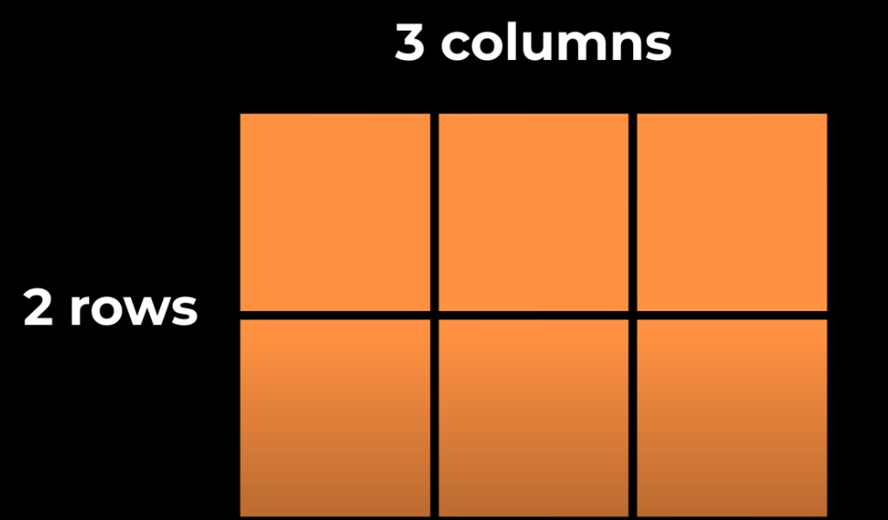

NOTE : In Gridbox we first define the order & width of the row/columns and the elements then go inside the row/columns respectively.

<!DOCTYPE html>

<html lang="en">

  <head>

    <meta charset="UTF-8" />

    <meta name="viewport" content="width=device-width, initial-scale=1.0" />

    <title>Document</title>

    <style>

        .color1{

            background-color: lightblue;

        }

        .color2{

            background-color: lightpink;

        }

        .grid1{

            display: grid;

            grid-template-rows: 50px 50px;

            margin-bottom: 20px;

        }

        .grid2{

            display: grid;

            grid-template-columns: 50px 50px;

        }

    </style>

  </head>

  <body>

    <div class="grid1">

      <div class="color1">div1</div>

      <div class="color2">div2</div>

    </div>

    <div class="grid2">

        <div class="color1">div1</div>

        <div class="color2">div2<p>Hi</p></div>

</div>

  </body>

</html>

e.g 2:

       .grid1{

            display: grid;

            grid-template-columns: 50px 100px 50px; // as we have specified 3 cols

        }

    </style>

  </head>

  <body>

    <div class="grid1">

      <div class="color1">50px</div>

      <div class="color2">100px</div>

      <div class="color1">50px</div>

      <div class="color2">100px</div> //when we add the 4th element it will work //like flow layout and bring it to next row

    </div>

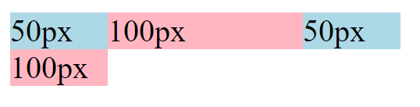

e.g 3 :

 .grid1{

            display: grid;

            grid-template-columns: 50px 100px 1fr; //fr means free space

        }

<div class="grid1">

      <div class="color1">50px</div>

      <div class="color2">100px</div>

      <div class="color1">50px</div>

    </div>

Here the 3rd col will take the remainder of the space , so when u resize the browser window it will expand and shrink



e.g 4 :

 .grid1{

            display: grid;

            grid-template-columns: 50px 100px 1fr 1fr; //1st col fix 50px 2nd col fix 100px now remainder width will be split equally

between the 3rd and the 4th col in the ration 1:1

        }

    </style>

  </head>

  <body>

    <div class="grid1">

      <div class="color1">50px</div>

      <div class="color2">100px</div>

      <div class="color1">50px</div>

      <div class="color2">100px</div>

    </div>



e.g 5:

     .grid1{

            display: grid;

            grid-template-columns: 10px 20px 1fr 2fr; //1st col fix 50px 2nd col fix 100px now remainder width will be split in proportion

of 1:2 between the 3rd and the 4th col

        }

    </style>

  </head>

  <body>

    <div class="grid1">

      <div class="color1">10px</div>

      <div class="color2">20px</div>

      <div class="color1">33%</div>

      <div class="color2">67%</div>

    </div>



e.g 6 :

  .color1{

            background-color: lightblue;

            height: 200px;

        }

        .color2{

            background-color: lightpink;

            height: 200px;

        }

        .grid1{

            display: grid;

            grid-template-columns: 1fr 1fr 1fr;

        }

    </style>

  </head>

  <body>

    <div class="grid1">

      <div class="color1">1fr</div>

      <div class="color2">1fr</div>

      <div class="color1">1fr</div>

    </div>



e.g 7

  <div class="color1">1fr</div>

      <div class="color2">1fr</div>

      <div class="color1">1fr</div>

      <div class="color2">1fr</div> //if we add an extra element as mentioned it will flow layout

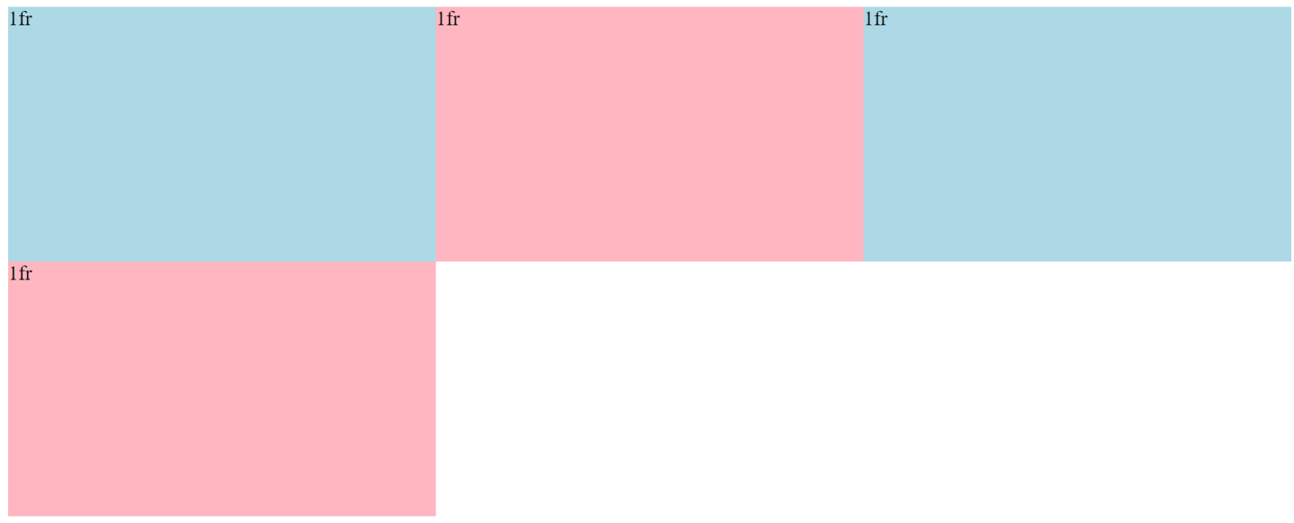

e.g 8:

<div class="grid1">

      <div class="color1">1fr</div>

      <div class="color2">1fr</div>

      <div class="color1">1fr</div>

      <div class="color2">1fr</div>

      <div class="color1">1fr</div>

      <div class="color2">1fr</div>

    </div>

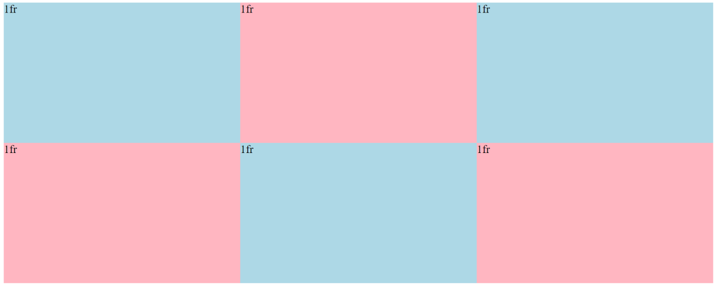

e.g 9 :

 .grid1{

            display: grid;

            grid-template-columns: 1fr 1fr 1fr;

            column-gap: 20px;

            row-gap: 20px;

        }

